**Obsah**

1. Containers 2

2. Kubernetes and Docker Swarm 3

2.1. Master node, Worker node 4

1. Containers

They package your application and isolate it.

Benefits of containers in the cloud:

1. Regular: portability, speed, ease of automation
2. Save money – use less resources
3. Container Support out of the box – most cloud platforms provide services built specifically for containers.
4. Kubernetes and Docker Swarm

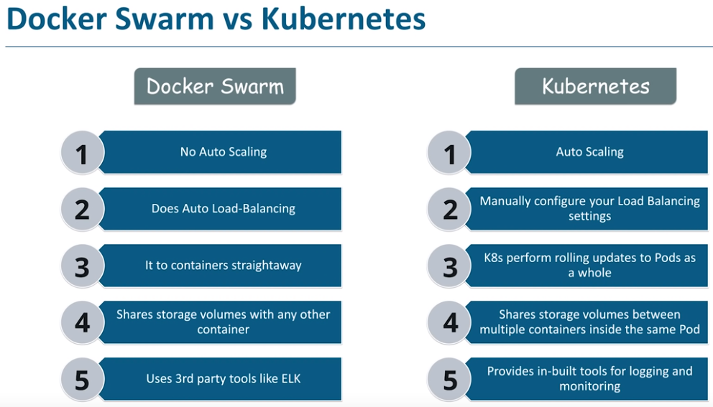

Containers need to be managed and connected to the outside world for tasks such as scheduling, load balancing and distribution. This is where a container orchestration tool like Kubernetes comes into its own. Rolling updates, logging and monitoring.

Kubernetes is an open source container orchestration platform, for automating deployment, scaling and management of containerized applications.

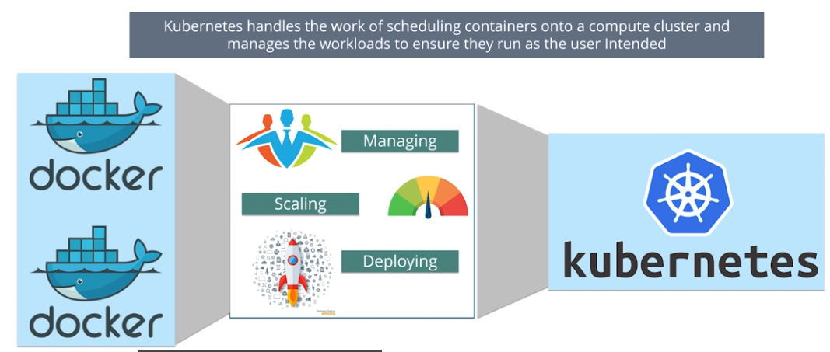

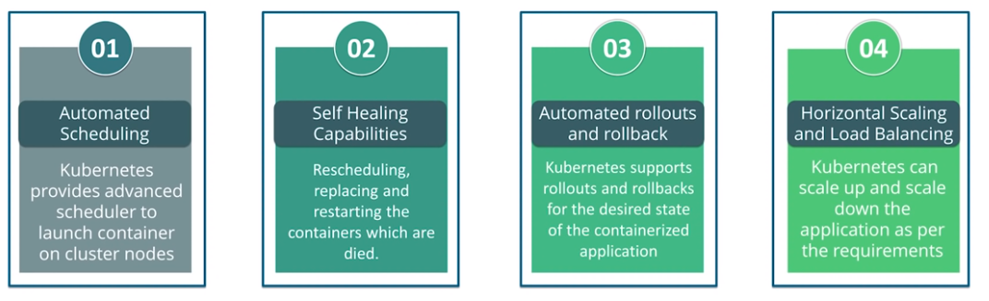

* 1. Master node, Worker node

1. Python for system administrators

* The subprocess module
* The subprocess.run function
* The subprocess.CompletedProcess class
* The subprocess.PIPE object (stdout)
* The bytes type
* The subprocess.CalledProcessError class